Project Development Phase Model Performance Test

Date | 01 Feb 2026
Team ID | LTVIP2026TMIDS34329
Project Name | Toycraft tales: tableau's vision into toy manufacturer data
Maximum Marks | 4 Marks

Model Performance Testing:
Project team shall fill the following information in model performance testing template.

S.N  o. | Parameter | Screenshot / Values
1 | Data Rendered | 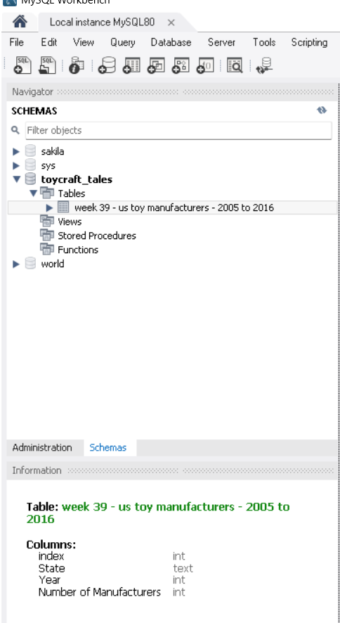
2. | Data Preprocessin g | 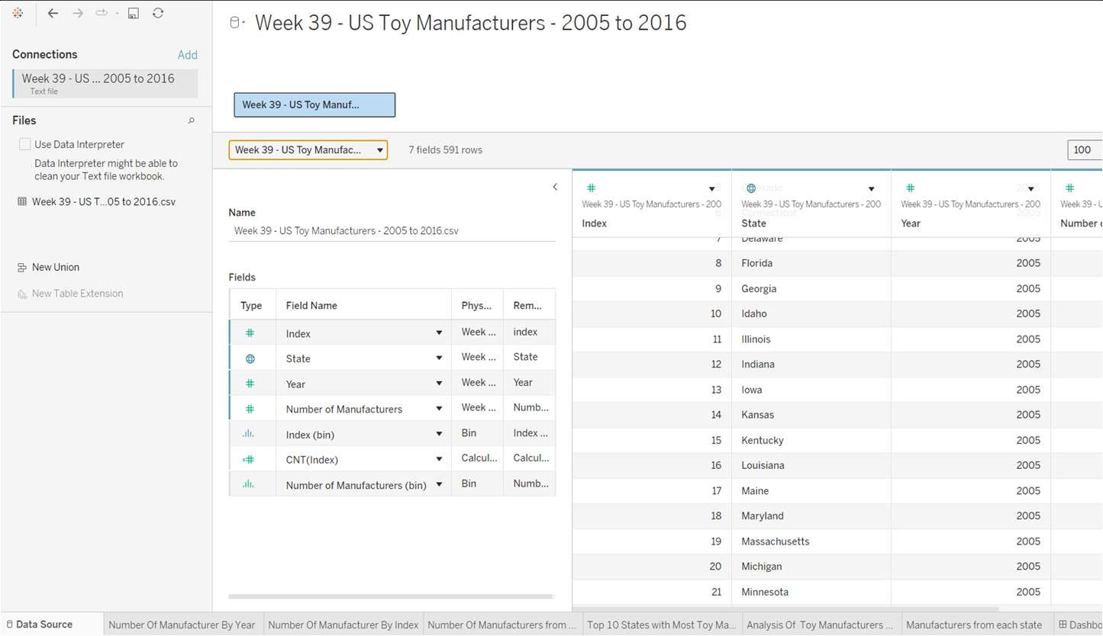

3. | Utilization of Filters | The fields Year and State are majorly used as Filters.
4. | Calculation fields Used | Index(BIN), CNT(Index) are the calculation fields used for analysis.
5. | Dashboard design | No of Visualizations / Graphs – 6  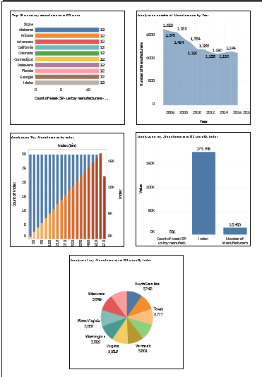
6 | Story Design | No of Visualizations / Graphs –5  